Project Development Phase Sprint - 3

|  |  |
| --- | --- |
| Team ID | PNT2022TMID08113 |
| Project Name | Project - Retail Store Stock Inventory Analytics |

**SPRINT -3**

Dashboard Creation

**Dataset Link:** <https://drive.google.com/file/d/1awFIKJ9LiIdnNHwGLcsqNDbbwshFHR-w/view> **Load the Dataset:**

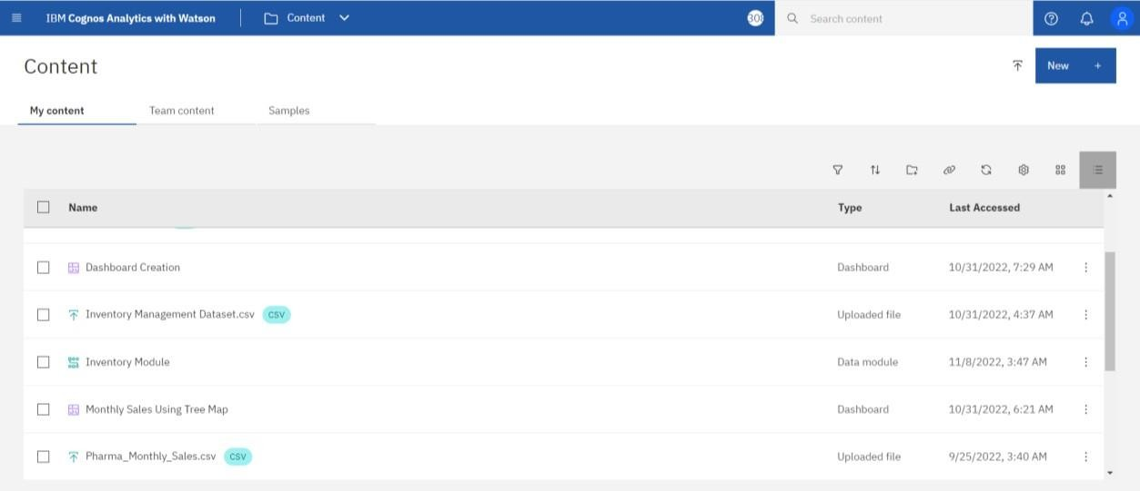

**Selecting the Prepared data:**

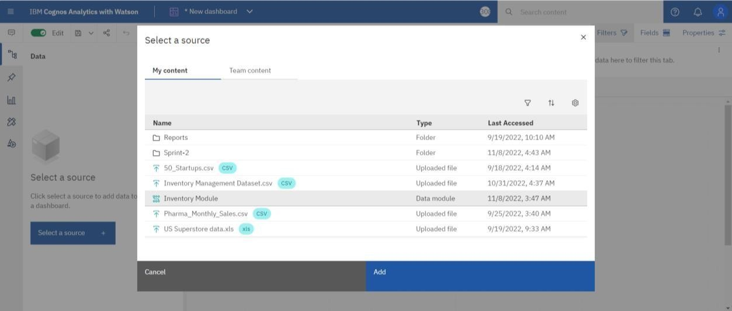

Dashboards: Dashboard 1:

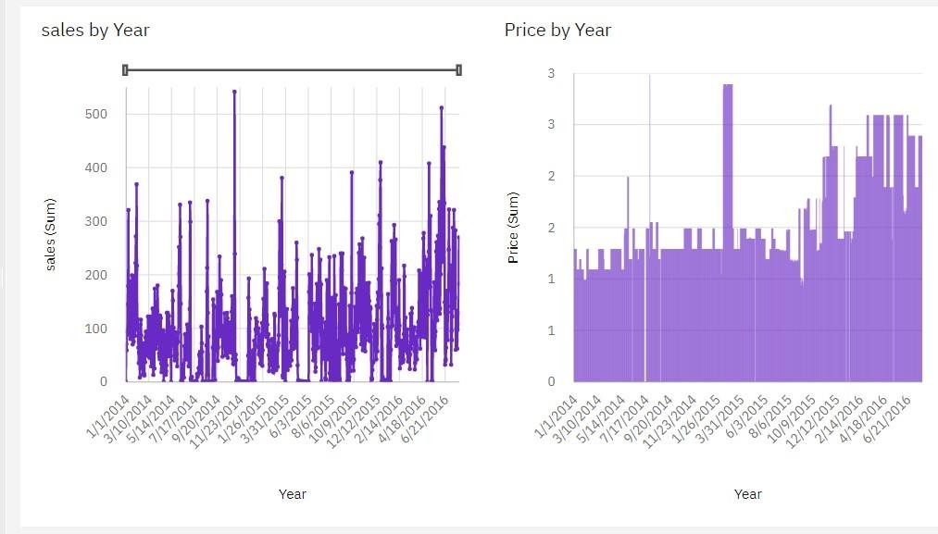

Dashboard 2:

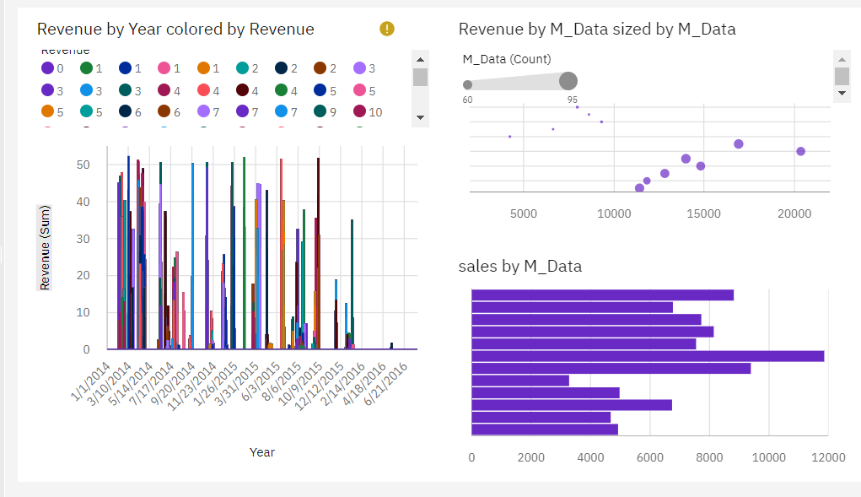

Dashboard 3:

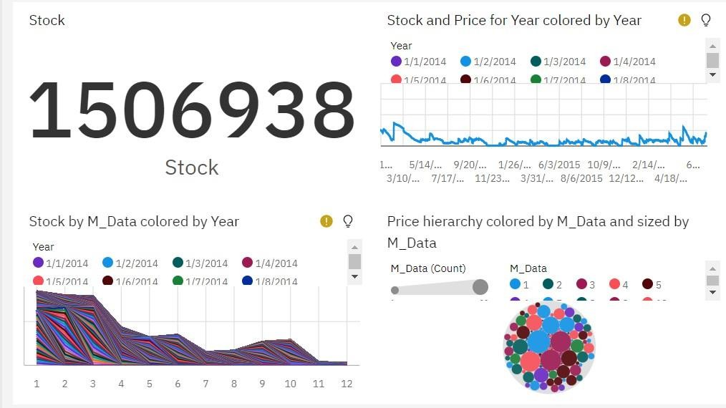

Dashboard 4:

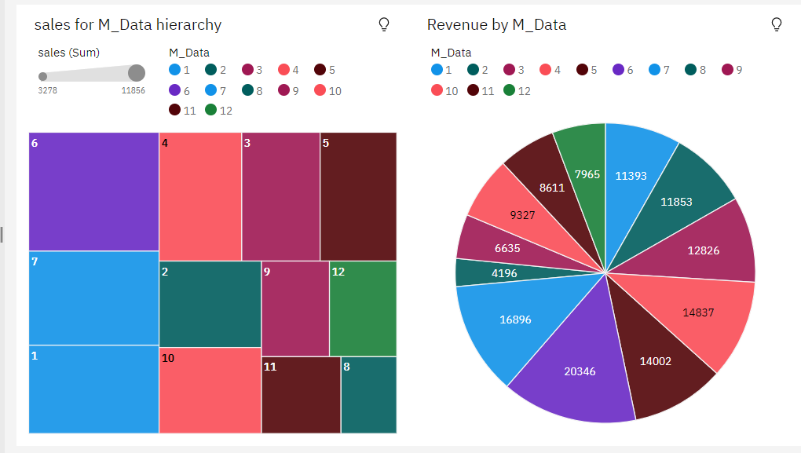

Dashboard 5:

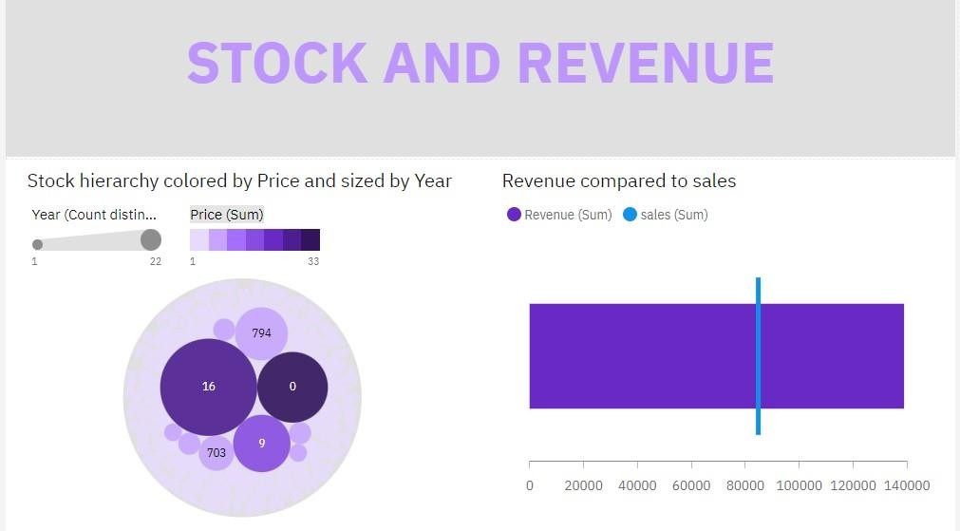

Dashboard 6:

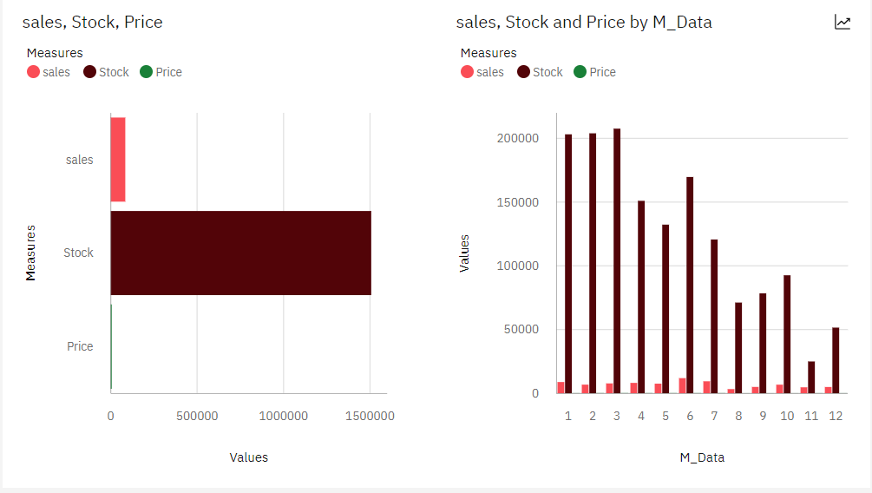

Dashboard 7:

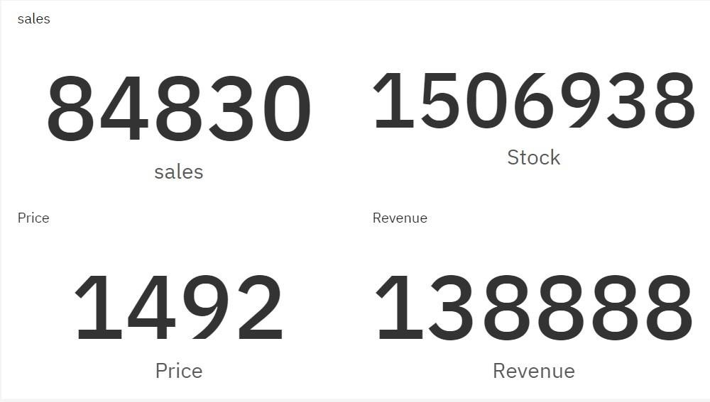

Dashboard 8:

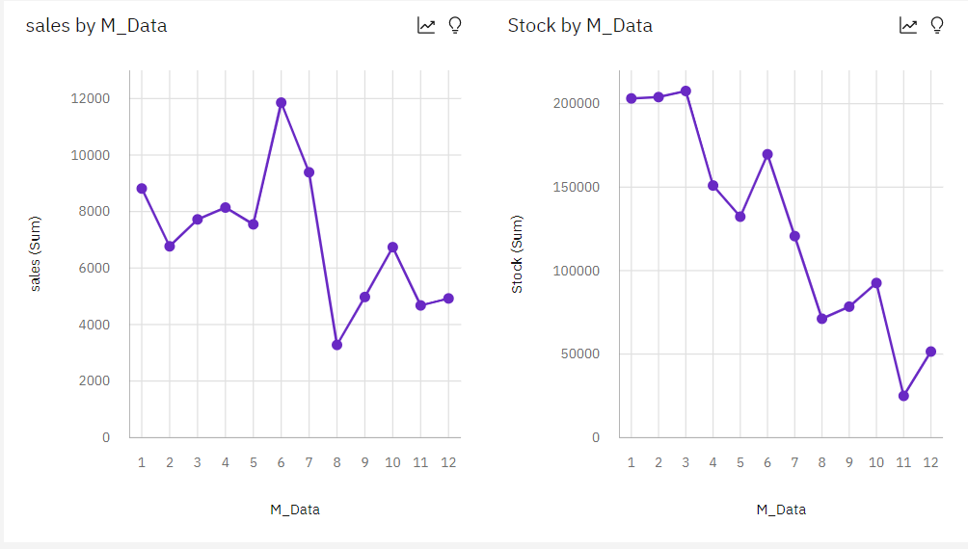

Prepared Dashboard Link:

https://us3.ca.analytics.ibm.com/bi/?perspective=content&folder=.my_folders%2FDa shboards